[**https://arna.cpplgmp.com/#/master/equipments**](https://arna.cpplgmp.com/#/master/equipments)

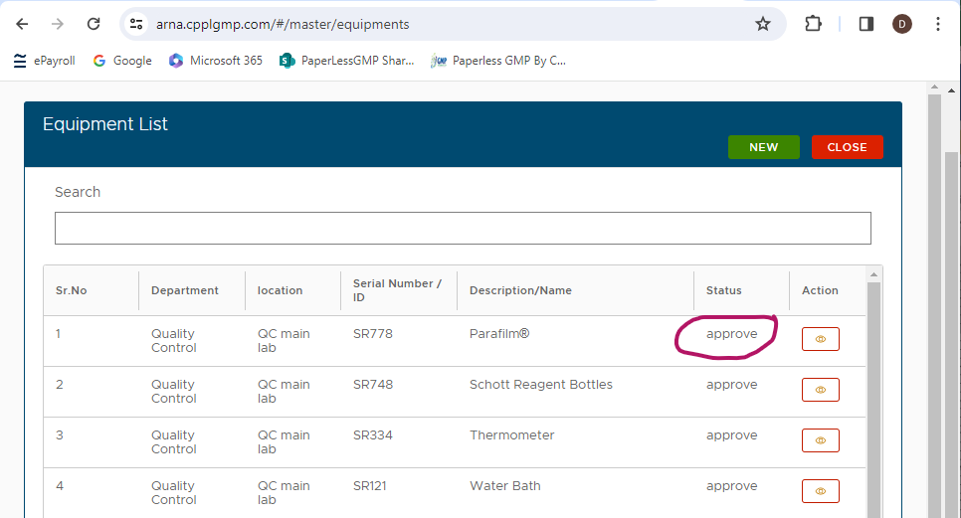

* Please advise whether this ‘Status’ indicates that the equipment is currently approved (if so, change wording from ‘approve’ to ‘Approved’) or is waiting to be approved (if so, ‘Pending Approval’ may be clearer).
* Could you please advise what the different Status options will be (will this include Approved for Use, Decommissioned, Not Yet Implemented)?
* The button in the ‘Action’ column does not link to any action.

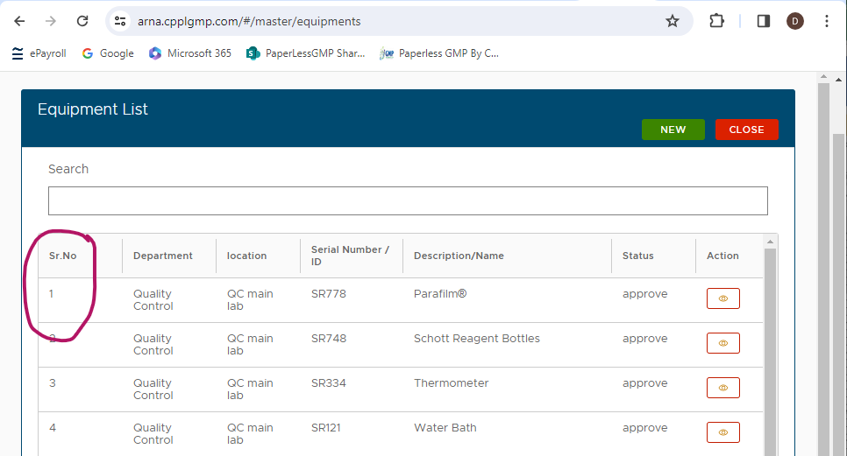

* Please provide explanation for ‘Sr.No’.

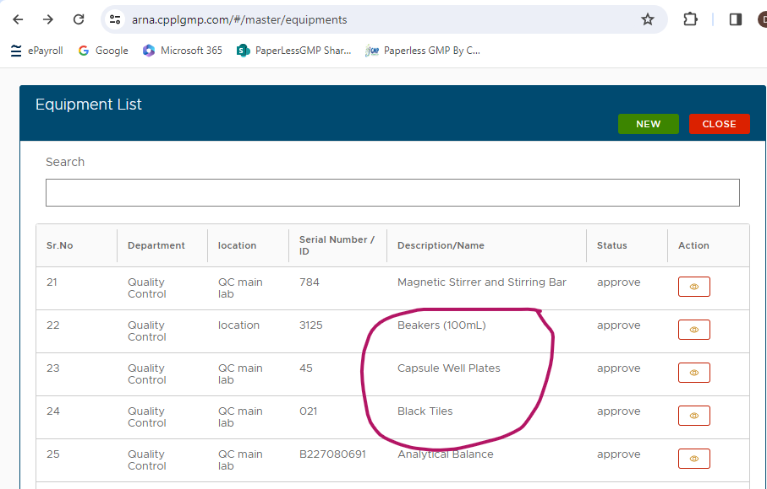

* Please note that there are items which are probably better considered as consumables currently included in the equipment list (these do not get individual Tag/ID numbers etc).

[**https://arna.cpplgmp.com/#/master/equipments/new**](https://arna.cpplgmp.com/#/master/equipments/new)

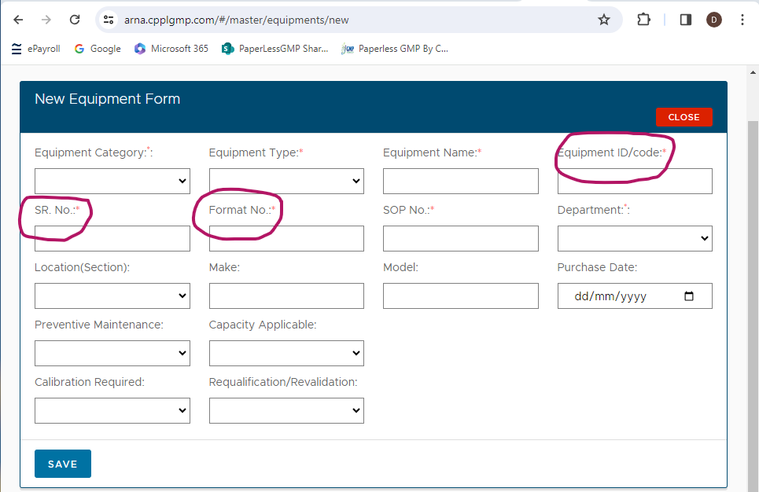

* Can you please advise how these fields align with our current equipment identification (Tag Number) system?
* How documents for forms / checklist linked to the equipment are ID?

**Equipment with Multiple Components**

Does the New Equipment Form have functionality to record additional components of a system which will be considered one piece of equipment (i.e. have one Tag Number) but components may have separate serial numbers?

* For example, the Mass Set and HPLC as shown in our current Equipment ID Log have multiple components with individual serial numbers:

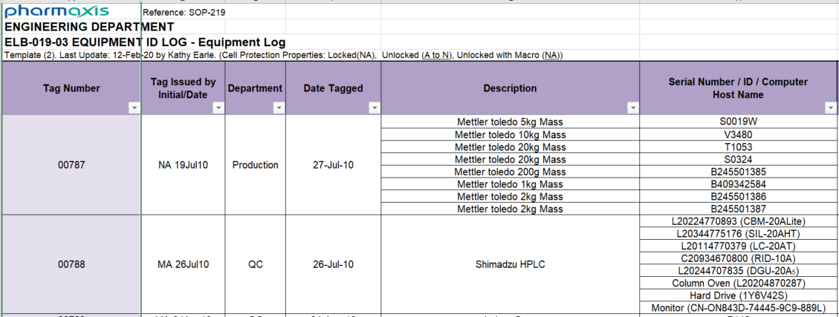

It would be beneficial to be able to detail when equipment has more than one component, describe the components and detail the individual serial numbers for these, see the table below for an example of how the information for Tag 00787 would be presented if fields were available to list components and their relevant tag numbers.

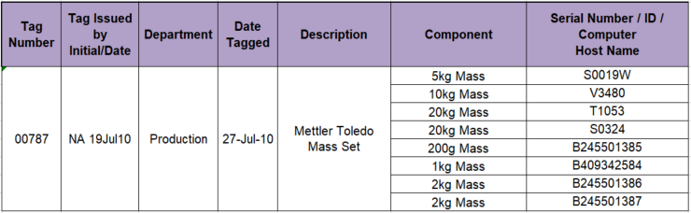

**Comment Regarding Capacity Fields**

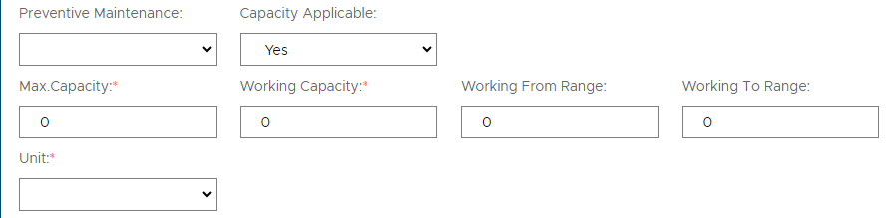

The ‘Max Capacity’, ‘Working Capacity’, ‘Working From Range’ and ‘Working To Range’ will be more functional if the number can be entered directly rather than having to press the up arrow until the desired value is reached (particularly for the Max and Working Capacity fields which are increasing in increments of 0.01).

How is this linked with checklist of preventive maintenance or calibration ?

**Link to Existing Equipment Implementation Procedure**

When a New Equipment Form is raised, how will this link to workflows for implementation of new equipment as detailed in SOP-219-11 Equipment Policy and FM-206-06 Equipment Implementation Record.

* Is there a workflow available for review for the procedure for implementation of new equipment including:
  + Documentation of physically tagging (and if applicable barcoding) the equipment,
  + Assessment of qualification requirements,
  + Completion of required qualifications,
  + Review and release for use?

1. 'Parent ID' row is required to link with Parent Equipment.
2. Lacking attributability of master equipment being added. Needs row for ‘Added By with Date’ system generated ES with date and time Stamp.
3. Need Date tagged column to identified when was the physical tag has been put on the equipment.

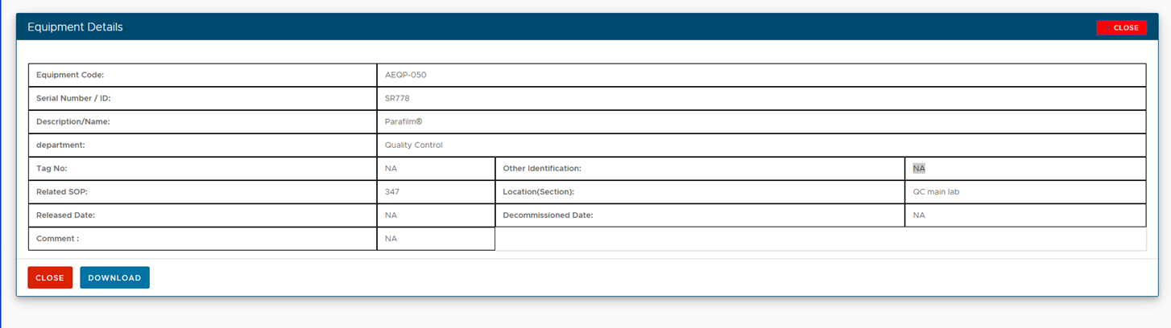

1. We don’t need serial number but Tag Number in the format XXXXX (For 01215) – This is the primary key which has to be referenced in other places like EBM, BMR, Testing, Change control. Deviation and CAPA.
2. State/ status of the equipment whether it is Active or decommissioned is missing.
3. Search function does not work with any other field data but only with Serial number.
4. There is no filter option.
5. Download button both of Equipment list page and Equipment details page down the same.
6. What about equipment IDs which have to decommissioned ? status and how to disable them ?

